

**Individual Coursework Submission Form**

Specialist Masters Programme

|  |  |
| --- | --- |
| **Surname: Parashar** | **First Name: Tridev** |
| **MSc in: Business Analytics** | **Student ID number: 180032806** |
| **Module Code: SMM750** | |
| **Module Title: Digital Technologies and Value Creation (DTVC)** | |
| **Lecturer: Dr. Philippe Blaettchen** | **Submission Date: 16 Dec 2022** |
| **Declaration:**  By submitting this work, I declare that this work is entirely my own except those parts duly identified and referenced in my submission. It complies with any specified word limits and the requirements and regulations detailed in the coursework instructions and any other relevant programme and module documentation. In submitting this work, I acknowledge that I have read and understood the regulations and code regarding academic misconduct, including that relating to plagiarism, as specified in the Programme Handbook. I also acknowledge that this work will be subject to a variety of checks for academic misconduct.  We acknowledge that work submitted late without a granted extension will be subject to penalties, as outlined in the Programme Handbook. Penalties will be applied for a maximum of five days lateness, after which a mark of zero will be awarded. | |
| **Marker’s Comments (if not being marked on-line):** | |

**%**

**Deduction for Late Submission: Final Mark:**

SMM 750

DTVC Final Course Project

**NOTE – For Section A, only references from Jupyter Notebook (Predictive Model and Group Categories) have been included. For main text, refer to the Jupyter Notebook. For Section B, the main text for Optimization model can be found below. Request you to refer to the Optimization Model excel file simultaneously.**

**Section A**

As discussed on the python notebook, the inputs or features to be plotted has been divided into two parts i.e., dummy variables and non-dummy variables. The interpretation of the graphs can be found on the two tables below –

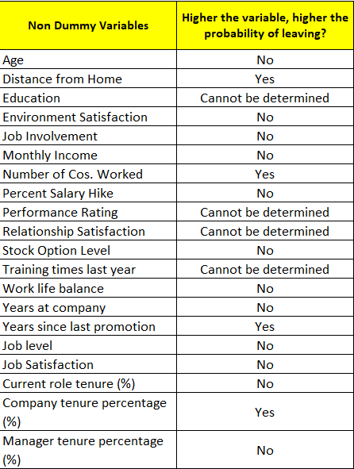 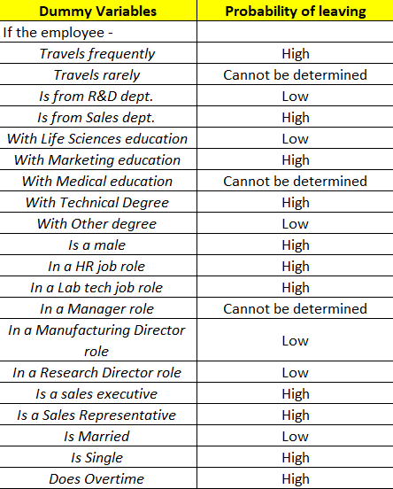

As per the criteria given on the python notebook, we will be focusing on the highlighted (red) variables to build combinations in order to define the categories of employees.

**Important thing to note before moving on to combinations used for categories –**

* An employee might be eligible to be allocated to multiple groups (which is not possible). Hence, we follow a preferential allocation mode wherein Group 1 has the highest preference of allocation and Group 8 has the least. E.g. – If an employee is eligible for both Group 3 and Group 4, he/she will be allocated to Group 3.
* The average thresholds calculations for ‘higher than average’ statements given below can be found on the python notebook.

**Group 1 –**

* R&D dept. employees with a higher than average distance from home
* Employees with a life sciences education with a higher than average distance from home
* Employees with other degrees and a higher than average distance from home

**Group 2 –**

* Manufacturing directors with a higher than average distance from home
* Research Directors with a higher than average distance from home
* Married employees with a higher than average distance from home

**Group 3 –**

* R&D dept. employees with a higher than average number of companies worked for
* Employees with life sciences education with a higher than average number of companies worked for
* Employees with other degrees with a higher than average number of companies worked for

**Group 4 –**

* Manufacturing directors with a higher than average number of companies worked for
* Research directors with a higher than average number of companies worked for
* Married employees with a higher than average number of companies worked for

**Group** **5 –**

* R&D employees with a higher than average number of years since last promotion
* Employees with life sciences education with a higher than average number of years since last promotion
* Employees with other degrees with a higher than average number of years since last promotion

**Group 6 –**

* Manufacturing directors with a higher than average number of years since last promotion
* Research directors with a higher than average number of years since last promotion
* Married employees with a higher than average number of years since last promotion

**Group 7 –**

* R&D employees who have spent a higher than average proportion time in the current company relative to total working years.
* Employees with life sciences education who have spent a higher than average proportion time in the current company relative to total working years.
* Employees with other degrees with a higher than average proportion time in the current company relative to total working years.

**Group 8 –**

* Manufacturing directors with a higher than average proportion time in the current company relative to total working years.
* Research directors with a higher than average proportion time in the current company relative to total working years.
* Married employees with a higher than average proportion time in the current company relative to total working years.

Using the following approach of allocation, we were able to allocate 333 employees into each of the categories. For the remaining 98 employees, we took a random approach wherein we allocated them in equal numbers to the groups with four (4) lowest count of employees within them.

For the purpose of ensuring minimal discrimination issues, we ought to verify the allocations within groups using the following table –

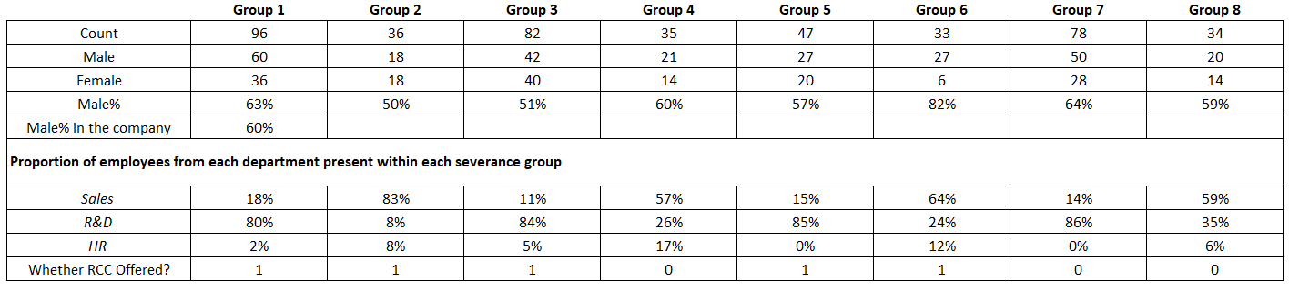

The results of the optimised model (given in section B) suggest that Groups 1, 2, 3, 5 and 6 shall be given an offer to leave (RCC). Comparing these groups only, the gender allocation for these groups seems to be in line with the overall gender composition in the company. The only exception here is Group 6, which has a higher than average number of males. Though the number of males are high in that group, the count of employees in that group is the least amongst the groups selected for an RCC. Hence, any significant discrimination issue in terms of gender is highly unlikely to be raised.

Secondly, the departmental compositions within each group also seems highly skewed towards R&D employees. But the fact that out of 441 employees in the company, 285 employees belong to the R&D department reaffirms the fact that R&D employees are bound to be significantly higher within the groups than others (except 2 and 6 where Sales has the highest count).

**Section B**

After creation of the eight (8) groups, we fit them on to the optimization model excel file based on the combinations discussed above. Firstly, we define the severance cost as per emails received from Maurice and Kusha, as follows –

* We firstly classified the employees based on the amount of time spent at SFB since only employees with a tenure of 8 months or more are eligible to receive a severance package.
* Regarding the base package, the instruction given on Maurice’s email has been followed i.e.

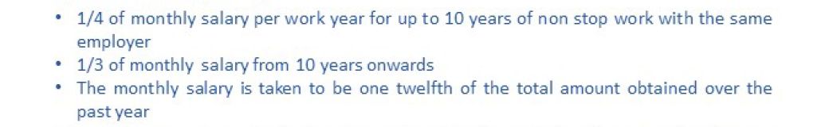

* Further, additional payments have been taken as 3 additional months of income for all employees instead of 2. This is a prudent approach since this would help us in gauging the maximum severance amount we may offer to the employees in case they are leaving.

The key elements in our optimization model are as follows:

* Decision Variables – The decision variables in this case would be which groups should be offered an RCC (a binary variable where 1 indicates RCC should be offered and 0 the opposite)
* Constraints – The constraints in this case denote the following - management expectations in terms of annual salary costs savings, minimum number of employees leaving, the number of people that should remain back in each department and a tolerance defined for each job role.
* Objective – Our objective in this case is to minimise the amount of severance costs paid out to employees with a higher probability of leaving and accepting the RCC.

In terms of constraints, without the presence of the additional constraints, the severance cost paid out is EUR 1,034,182 for 42 employees leaving. With the inclusion of both the additional constraints, the severance pay out is EUR 1,583,150 for 43 employees leaving. This might suggest that the addl. constraints act as a barrier to achieve a lower severance by EUR 548,968 with only 1 addl. employee leaving. But the addl. constraints ensure that a mass exodus is prevented and salary costs savings amount to more than management expectation.

The possible reason behind the increase in severance costs through inclusion of addl. constraints is that the optimised problem may now be considering more highly paid employees in order to ensure prospective savings targets are met, hence an increase in severance pay-outs. Highly paid employees also tend to spend a longer time in the company; hence a larger severance amount is offered to such employees.

The results of the optimization approach were that Groups 1, 2, 3, 5 and 6 will be offered to leave, and the resultant savings from salary cuts annually is EUR 3,008,617. Also, the departmental division of employees leaving are – Sales: 16, HR: 2, R&D: 26.

The results fulfil some of the implicit assumptions we have made i.e., -

* **Preventing a mass exodus** – Offers only being made to employee’s categories which are satisfying the constraints optimally.
* **Preventing severe departmental layoffs** – Offers being made to employee categories wherein the probability of leaving and accepting an RCC doesn’t result in massive attrition in any single department.
* **Number of employees in job roles will be able to support operations post attrition –** Defining tolerance levels for each job role and ensuring that the employees leaving does not put the reliability of any job roles at risk of operational continuity.

Additionally, some pros and cons of the optimization approach we have undertaken are as follows –

**Pros**

* **Objective Approach –** The optimization model considers both quantitative and qualitative data associated with employees to determine whether an employee should be offered to leave or not, which removes any kind of bias.
* **Consideration of management expectation –** The goal of any M&A activity is achieving a desired outcome for which the M&A activity was decided in the first place. Hence, the optimization approach takes into consideration such outcomes.

**Cons**

* **Resistance to RCC offers –** Employee groups, though found to be the best fit as per the optimization approach, may reject the offer to accept RCC. In such cases, an alternative strategy should be adopted based on understanding of human capital policies and not only limited to outputs delivered by the optimization approach.
* **Voluntary attrition –** Employee categories that may not be offered an RCC may also experience some amount of voluntary attrition in cases wherein employees might not be willing or comfortable to work in post M&A settings. Hence, employees need to be communicated regarding the benefits to be achieved post the integration and rewards policies should be initiated by the company for employees willing to continue their tenure in the merged entity.